//DEEPIKA SHARMA -124959

LAB -2.1 Single Row Functions:

- Display name and date of birth of students where date of birth must be displayed in the format similar to “January, 12 1981” for those who were born on Saturday or Sunday.
Ans. REFER TABLE: Student_Master
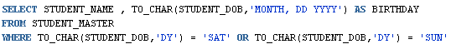
OUTPUT:
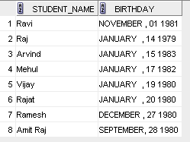
- Display each staff name and number of months they worked for the organization. Label the column as ‘Months Worked’. Order your result by number of months employed. Round the number of months to closest whole number.
Ans. REFER TABLE: Staff_Master
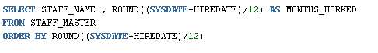
OUTPUT:
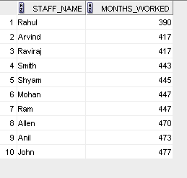
- List the details of the employees, whose names start with ‘A’ and end with ‘S’.
Ans. REFER TABLE: EMP
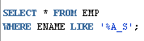
OUTPUT:
- List the name and job of the employees whose names should contain N as the second or third character, and ending with either ‘N’ or ‘S’.
Ans. REFER TABLE: EMP
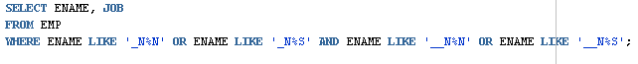
OUTPUT:
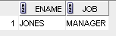
- Create a query which will display Staff Name, Salary of each staff. Format the salary to be 15 character long and left padded with ‘$’.
Ans. REFER TABLE: Staff_Master
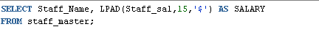
Output:
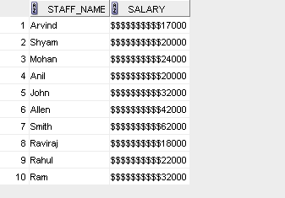
- List the names of the Employees having ‘_’ character in their name.
Ans. REFER TABLE: EMP
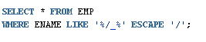
OUTPUT:
NO RECORD FOUND
- List the details of the employees who have joined in December (irrespective of the year).
Ans. REFER TABLE: EMP
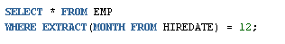

OUTPUT:
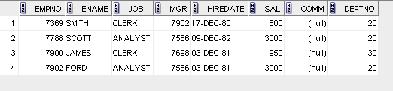
- Write a query that displays Staff Name, Salary, and Grade of all staff. Grade depends on the following table.

Salary | Grade
Salary >=50000 | A
Salary >= 25000 < 50000 | B
Salary>=10000 < 25000 | C
OTHERS | D

Ans. REFER TABLE: Staff_Master
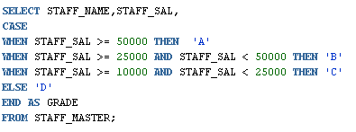
OUTPUT:
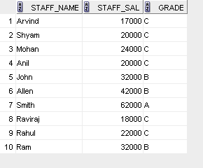
- Display the Staff Name, Hire date and day of the week on which staff was hired. Label the column as DAY. Order the result by the day of the week starting with Monday.
Ans. REFER TABLE: Staff_Master
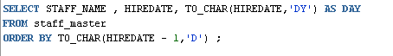
OUTPUT:
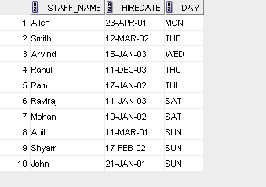
- Show staff names with the respective numbers of asterisk from Staff table.
Ans. REFER TABLE: Staff_Master
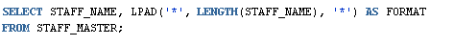
OUTPUT:
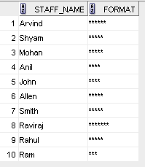
- Show staff names with the respective numbers of asterisk from Staff table except first and last characters. For example: KING will be replaced with K**G.
Ans. REFER TABLE: Staff_Master
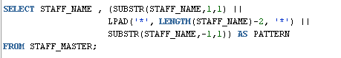
OUTPUT:
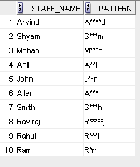
- Show all staffs who were hired in the first half of the month.
Ans. REFER TABLE: Staff_Master
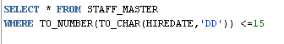
OUTPUT:
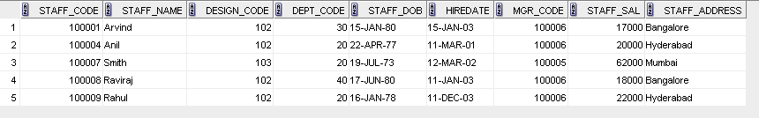

- Display the staff name, hire date and day of the week on which the staff joined. Order the results by the day of the week starting with Monday.
Ans. REFER TABLE: Staff_Master
OUTPUT:
- Write a query to find the position of third occurrence of ‘i’ in the given word ‘Mississippi’.
Ans.
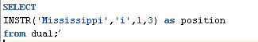
OUTPUT:
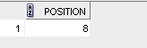
- Write a query to find the pay date for the month. Pay date is the last Friday of the month. Display the date in the format “Twenty Eighth of January, 2002”. Label the heading as PAY DATE.
Ans.
OUTPUT:
